C PROGRAMMING LAB REPORT

Time Conversion and Leap Year Verification
Prepared By: Reyansh Pandit
Course: B.Tech CSE Semester: I

Objective
To develop, compile, execute and test two C programs: converting seconds into days, hours, minutes and seconds, and checking whether a year is a leap year.
Software: GCC compiler / Linux terminal

QUESTION 1 — TIME CONVERSION

Problem Statement
Write a C program to input time in seconds and convert it into days, hours, minutes, and seconds format.
Input: Total time in seconds Output: Days, hours, minutes and seconds.

Logic
1 day = 86400 seconds, 1 hour = 3600 seconds and 1 minute = 60 seconds. Integer division gives the complete unit and modulus gives the remainder.

Algorithm
- Start.
- Input total seconds.
- days = total / 86400.
- remaining = total % 86400.
- hours = remaining / 3600.
- remaining = remaining % 3600.
- minutes = remaining / 60.
- seconds = remaining % 60.
- Display the result.
- Stop.

Pseudocode

START
INPUT total_seconds
days = total_seconds / 86400 remaining = total_seconds % 86400 hours = remaining / 3600 remaining = remaining % 3600 minutes = remaining / 60
seconds = remaining % 60
DISPLAY days, hours, minutes, seconds STOP

Flowchart
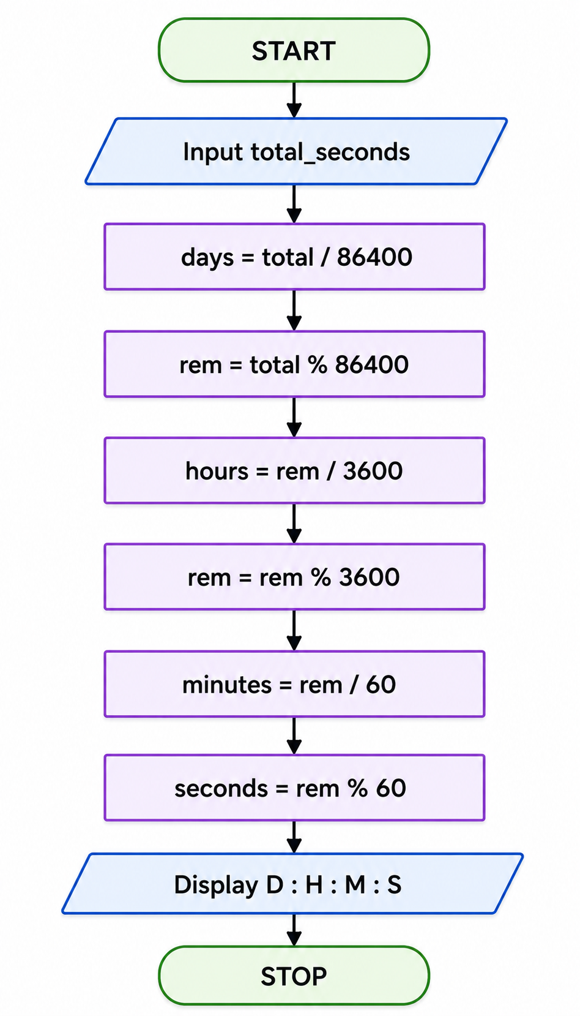

Test Case Table

TC | Input (s) | Expected Output | Purpose
1 | 0 | 0d 0h 0m 0s | Boundary
2 | 59 | 0d 0h 0m 59s | Under 1 minute
3 | 60 | 0d 0h 1m 0s | Exact minute
4 | 3661 | 0d 1h 1m 1s | Mixed units
5 | 86400 | 1d 0h 0m 0s | Exact day
6 | 90061 | 1d 1h 1m 1s | Mixed units

C Code
#include <stdio.h>

int main(void)
{
long long total_seconds, days, hours, minutes, seconds, remaining;

printf("Enter time in seconds: "); scanf("%lld", &total_seconds);

days = total_seconds / 86400; remaining = total_seconds % 86400; hours = remaining / 3600; remaining = remaining % 3600; minutes = remaining / 60;
seconds = remaining % 60;

printf("\nTime = %lld days, %lld hours, %lld minutes, %lld seconds\n", days, hours, minutes, seconds);

return 0;
}

COMPILE, EXECUTE & TEST
cc time_conversion.c
./a.out

Sample Execution
Enter time in seconds: 90061

Time = 1 days, 1 hours, 1 minutes, 1 seconds
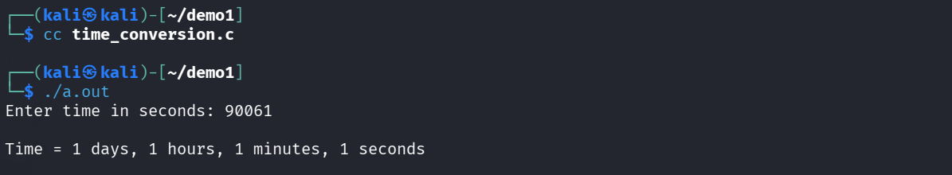

Test Results

TC | Input | Expected | Observed | Status
1 | 0 | 0d 0h 0m 0s | 0d 0h 0m 0s | PASS
2 | 59 | 0d 0h 0m 59s | 0d 0h 0m 59s | PASS
3 | 60 | 0d 0h 1m 0s | 0d 0h 1m 0s | PASS
4 | 3661 | 0d 1h 1m 1s | 0d 1h 1m 1s | PASS
5 | 86400 | 1d 0h 0m 0s | 1d 0h 0m 0s | PASS
6 | 90061 | 1d 1h 1m 1s | 1d 1h 1m 1s | PASS

Evaluation
All prepared test cases pass. The program correctly separates total seconds into days, hours, minutes and seconds.

QUESTION 2 — LEAP YEAR

Problem Statement
Write a C program to input a year and check whether it is a leap year or not.

Decision Rule
A year is a leap year if it is divisible by 400, OR if it is divisible by 4 and not divisible by 100.

Algorithm
- Start.
- Input year.
- Check: (year % 400 == 0) OR ((year % 4 == 0) AND (year % 100 != 0)).
- If true, display Leap Year.
- Otherwise, display Not a Leap Year.
- Stop.

Pseudocode

START
INPUT year
IF (year % 400 == 0) OR
((year % 4 == 0) AND (year % 100 != 0))
DISPLAY "Leap Year"

ELSE
DISPLAY "Not a Leap Year" END IF
STOP

Flowchart
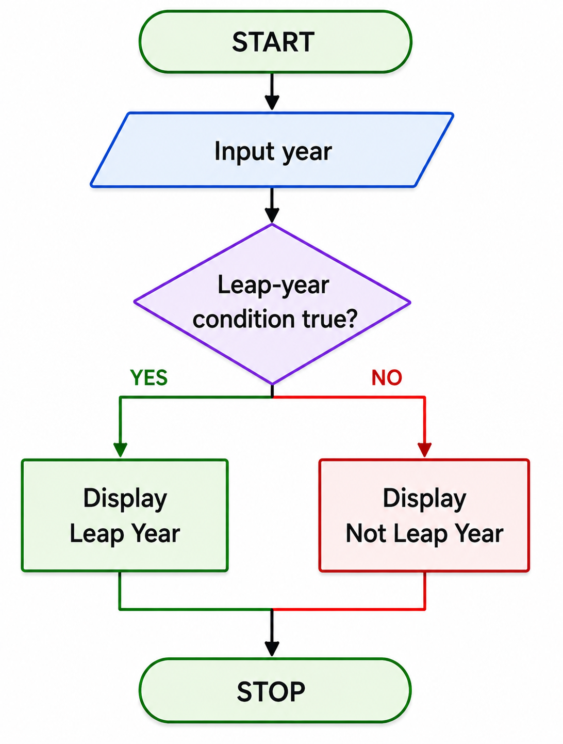

Test Case Table

TC | Year | Expected Output | Purpose
1 | 2024 | Leap Year | Divisible by 4
2 | 2023 | Not a Leap Year | Ordinary year
3 | 2000 | Leap Year | Century divisible by 400
4 | 1900 | Not a Leap Year | Century not divisible by 400
5 | 2400 | Leap Year | Century divisible by 400
6 | 2100 | Not a Leap Year | Century not divisible by 400

C Code
#include <stdio.h>

int main(void)
{
int year;

printf("Enter a year: "); scanf("%d", &year);

if ((year % 400 == 0) ||
((year % 4 == 0) && (year % 100 != 0)))
{
printf("%d is a Leap Year.\n", year);
}
else
{
printf("%d is not a Leap Year.\n", year);
}

return 0;
}

— COMPILE, EXECUTE & TEST
cc leap_year.c
./a.out

Sample Execution 1
Enter a year: 2024 2024 is a Leap Year.

Sample Execution 2
Enter a year: 1900
1900 is not a Leap Year.
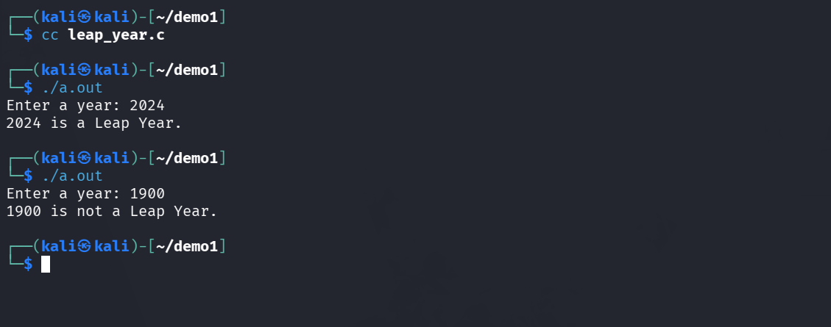

Test Results

TC | Input | Expected | Observed | Status
1 | 2024 | Leap Year | Leap Year | PASS
2 | 2023 | Not a Leap Year | Not a Leap Year | PASS
3 | 2000 | Leap Year | Leap Year | PASS
4 | 1900 | Not a Leap Year | Not a Leap Year | PASS
5 | 2400 | Leap Year | Leap Year | PASS
6 | 2100 | Not a Leap Year | Not a Leap Year | PASS

Evaluation
All prepared test cases pass, including century years. The program correctly applies the divisible-by-400 rule.

Overall Result
Both C programs were compiled and executed using GCC, and all listed use cases produced the expected results.

Conclusion
The experiments demonstrate arithmetic operations, integer division, modulus, conditional statements, algorithm design, pseudocode, flowchart construction, compilation, execution and systematic testing.

